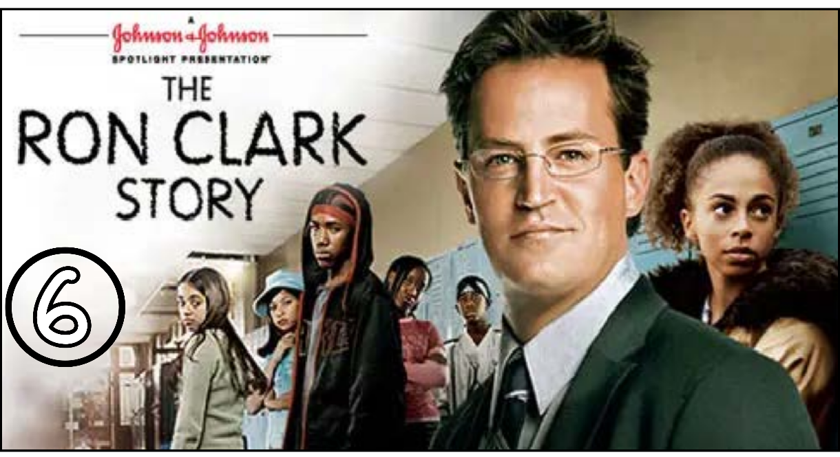
“The Ron Clark Story” (Scene 06)

Scene pparation

- Scene summary:
- In the scene Julio was surprised when Mr. Clack came back. Mr. Clack made a deal with the students: if they listen to the lesson quietly for 15 seconds, he will drink chocolate milk. If they don’t, he will puke. He managed to succeed in this challenge. Then, he made a second one with them. If they teach him how to jump rope, and he will teach them everything they need for the 7th grade . At the end , He learned how to play with the rope, but this behavior upset Mr. Turner .

- Scene Discussion & Analysis:

- Q01: Did Mr. Clark come back?
Yes , he did
- Q02: How did Mr. Clark get his students to follow with him?
He made a deal with them to drink chocolate milk each 15 seconds if they remain silent and focused .
- Q03: Did he actually puke eventually?
No , he didn’t .
- Q04: In your opinion, what does that demonstrate?
Mr. Clark’s students are unusual . They needed a different way of teaching . Mr. Clark understood that and when he changed his method he could grab their attention to follow with him . At the end of the session , some students could answer his questions . Therefore, these students are not stupid , they can actually learn .
Q05: What was the second deal he made with his students before they agreed to learn everything they need for 7th grade?
The second deal was that if they teach him how to double Dutch , they have to learn everything to pass the 7th grade .
- Q06: Did he succeed, eventually? Did Mr. Turner accept his acting? And why?
Yes , he did and Mr. Turner didn’t like his acting because he is unable to understand Mr. Clark’s unusual ways of teaching . He doesn’t trust his method to get him great scores at the end of the year .

- Acquired Vocabulary (OPTIONAL):

- Crazy mad:
- Example in a sentence:
“ The students think that the teacher are being crazy mad “
“ This man is actually crazy mad “
- Gone for good / To go for good
- Example in a sentence:
“ After the argument , Sara decided to leave the group chat for good and now , she’s gone for good “
- To puke : to throw up
- Example in a sentence:
“ She ate something bad and puked “

- Irregular Verbs:

Infinitive | Past simple | Past participle
To eat | ate | Eaten
To hear | Heard | Heard
To feel | Felt | Felt
To come | Came | Come
To go | Went | Gone

Additional Exercise (Optional)

Task: Transcribe sentences from the scene.

- Transcribe Sentence 01
- Well, thanks for your advice son but if Mr. Clark isn’t in his class I’m sure we can find someone to cover for him.

- Transcribe Sentence 02
Within these four walls you can be strangers or you can be a family. Within these four walls can be the end of your story or you can make it a beginning.

- Transcribe Sentence 03 gong
You really think it appropriate to do this with students ?!

